**Naman Kothari:-**

**SCREENSHOTS:-**

**Unity Essentials Legacy:**

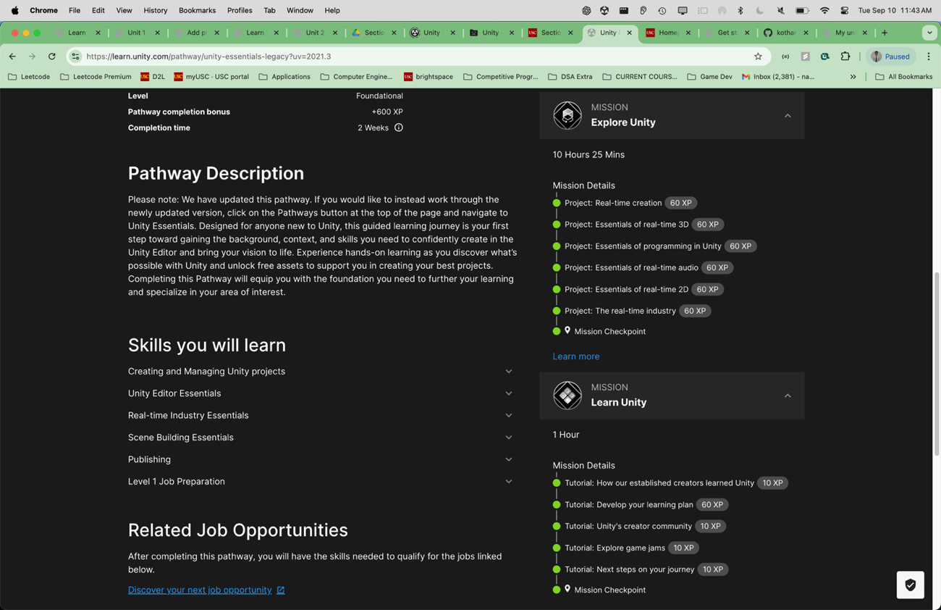

Since its showing missions 0/3. Here are the missions done screenshots:- 1-(Get Started With Unity)

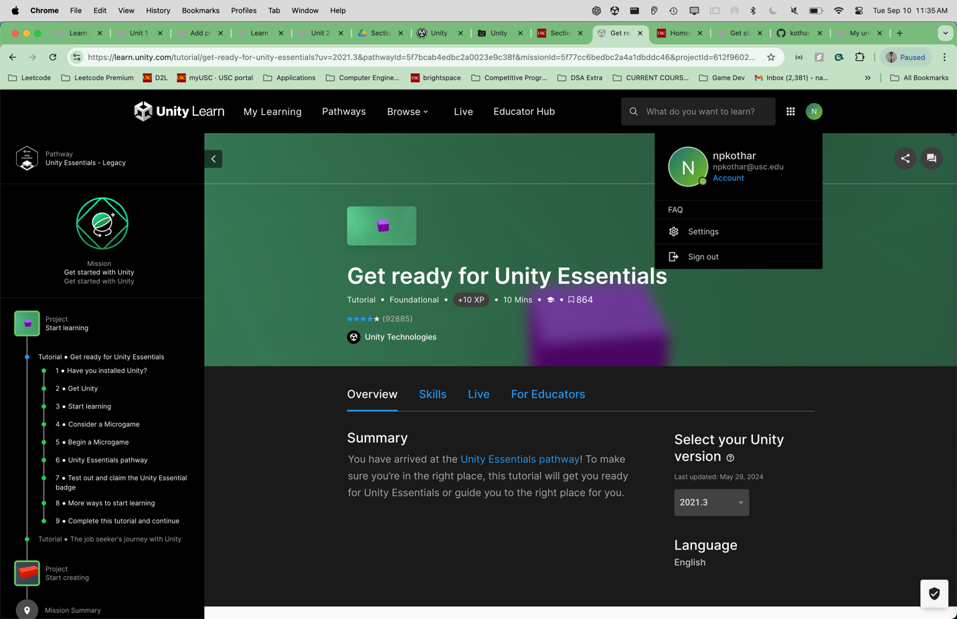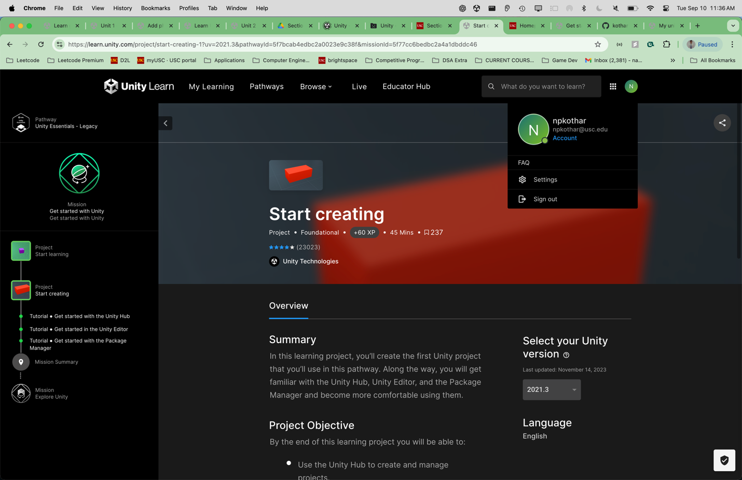

Mission Summary:-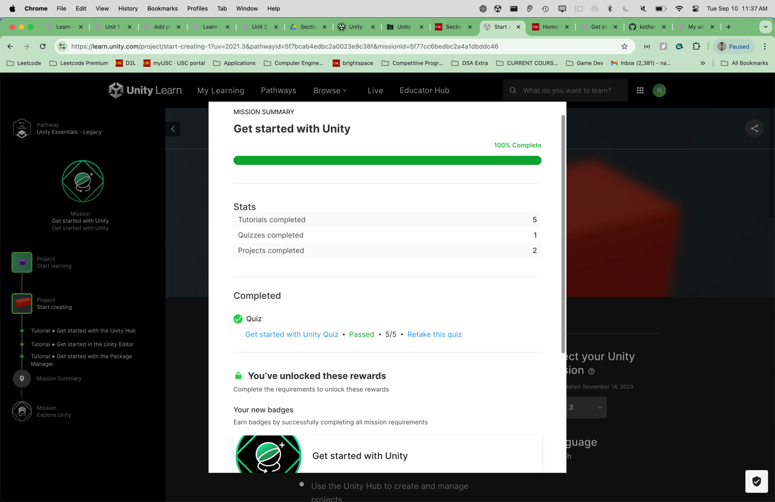

Explore Unity:-

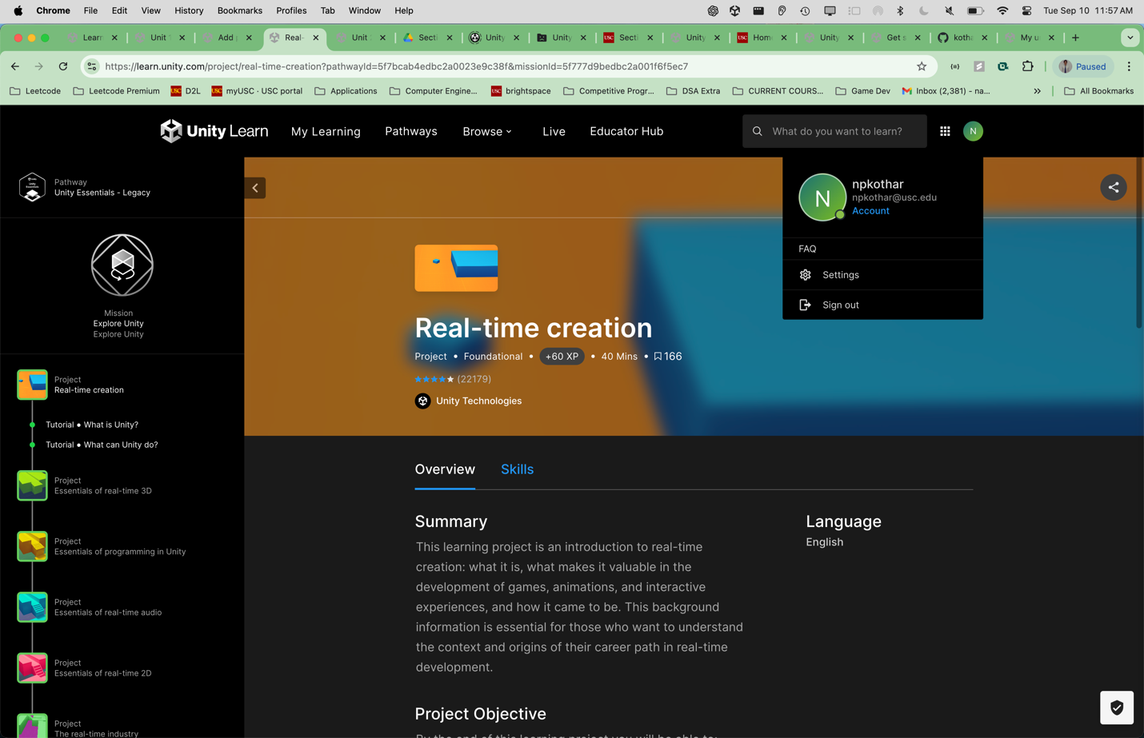

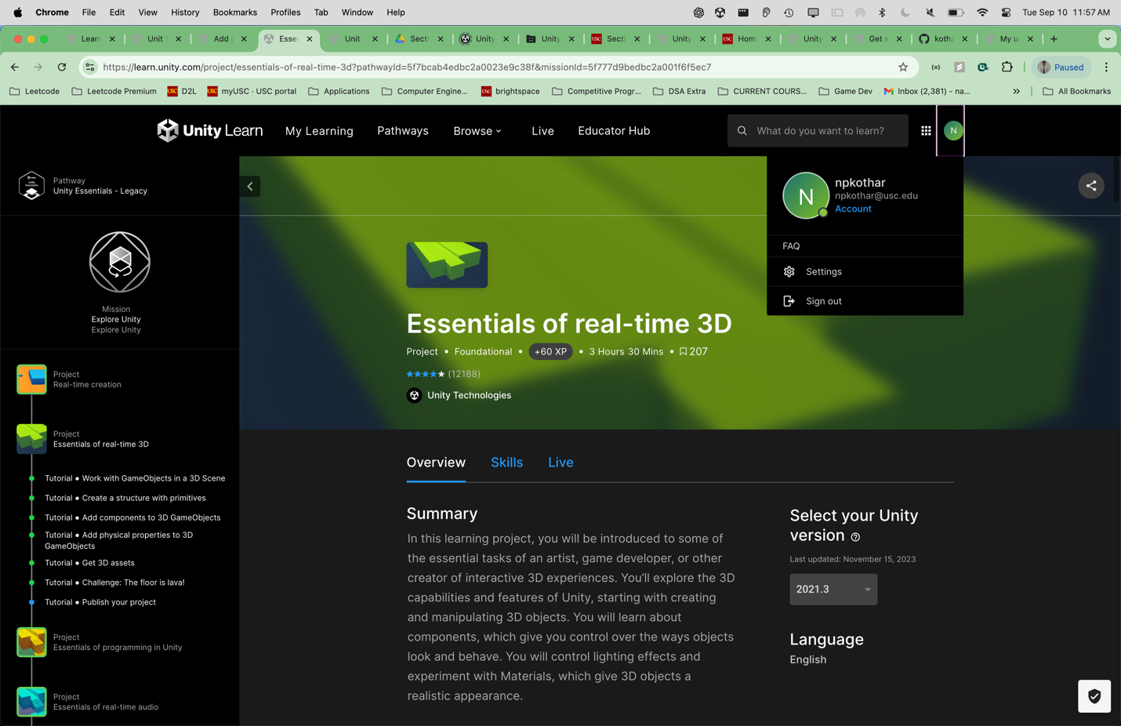

2.1 – Proof of submission: (since its still showing blue dot on the left)

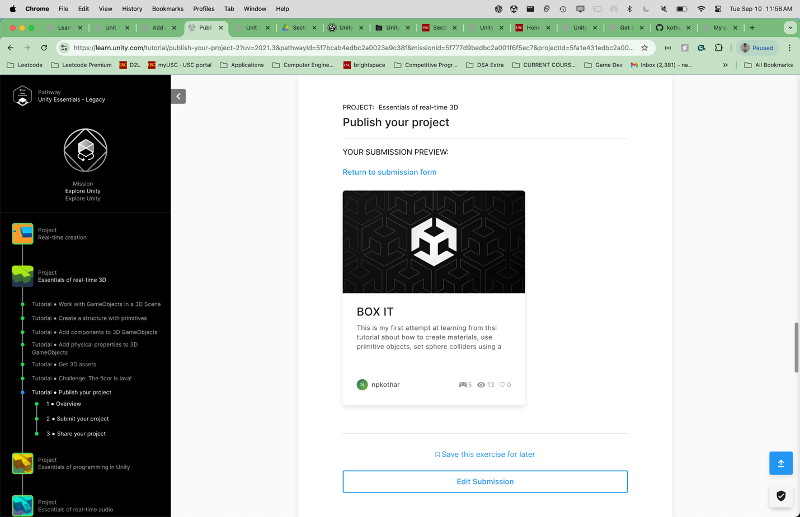

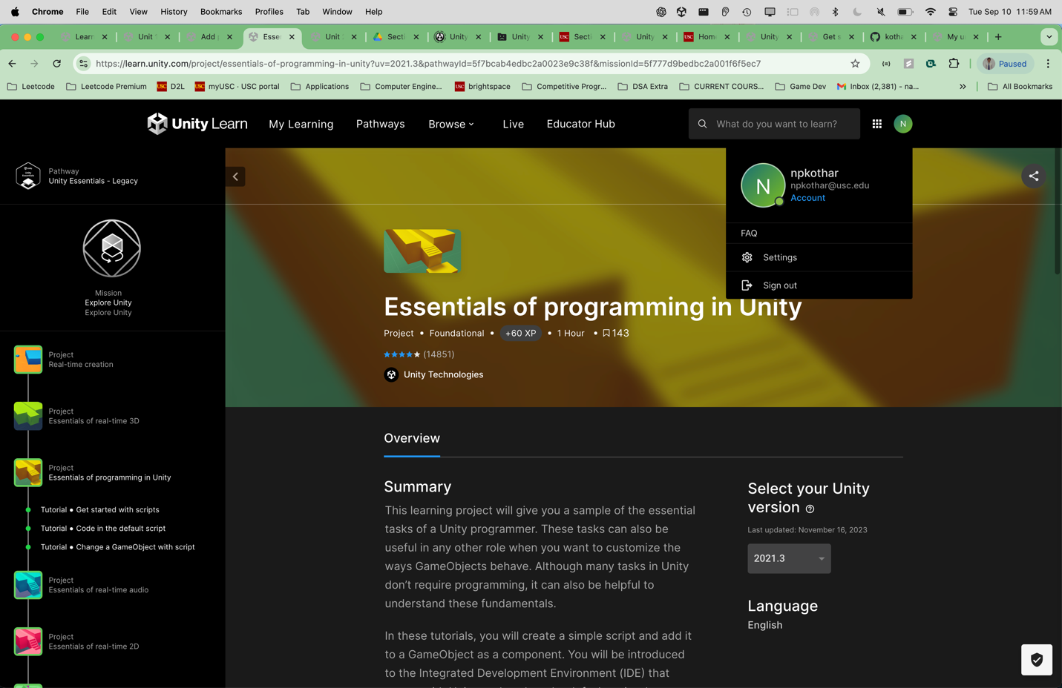

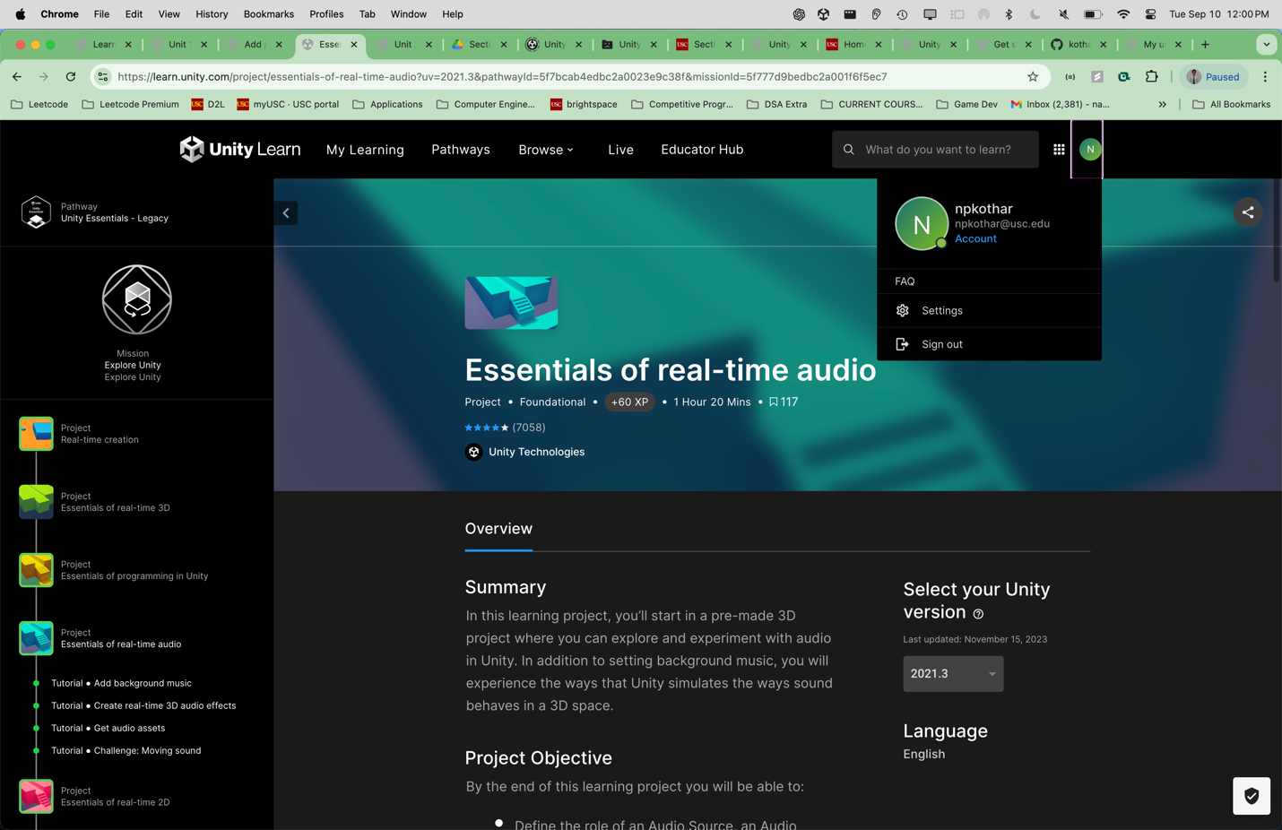

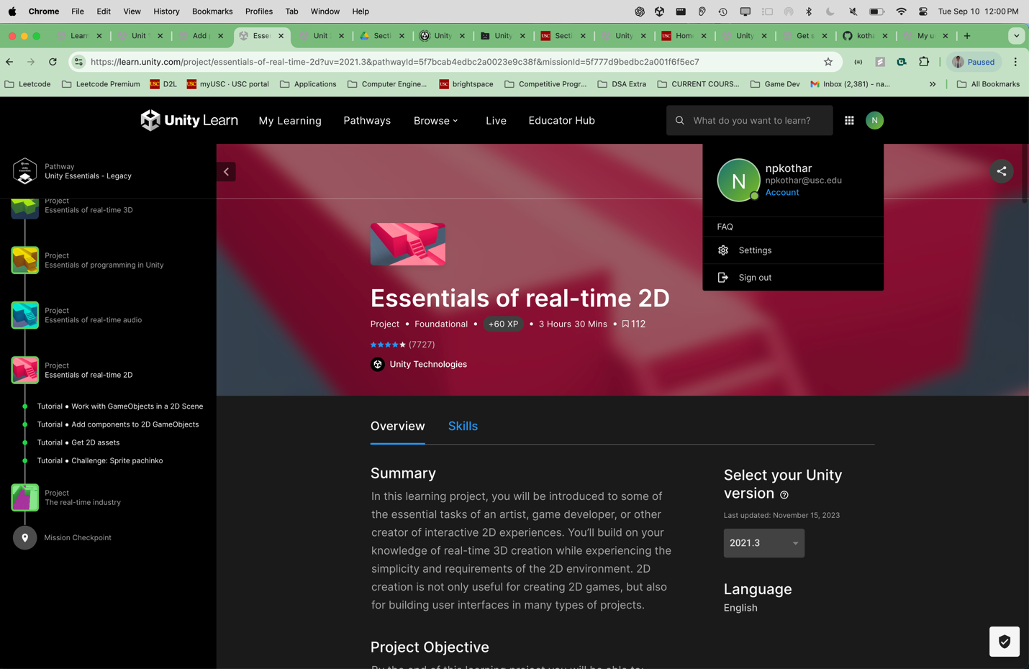

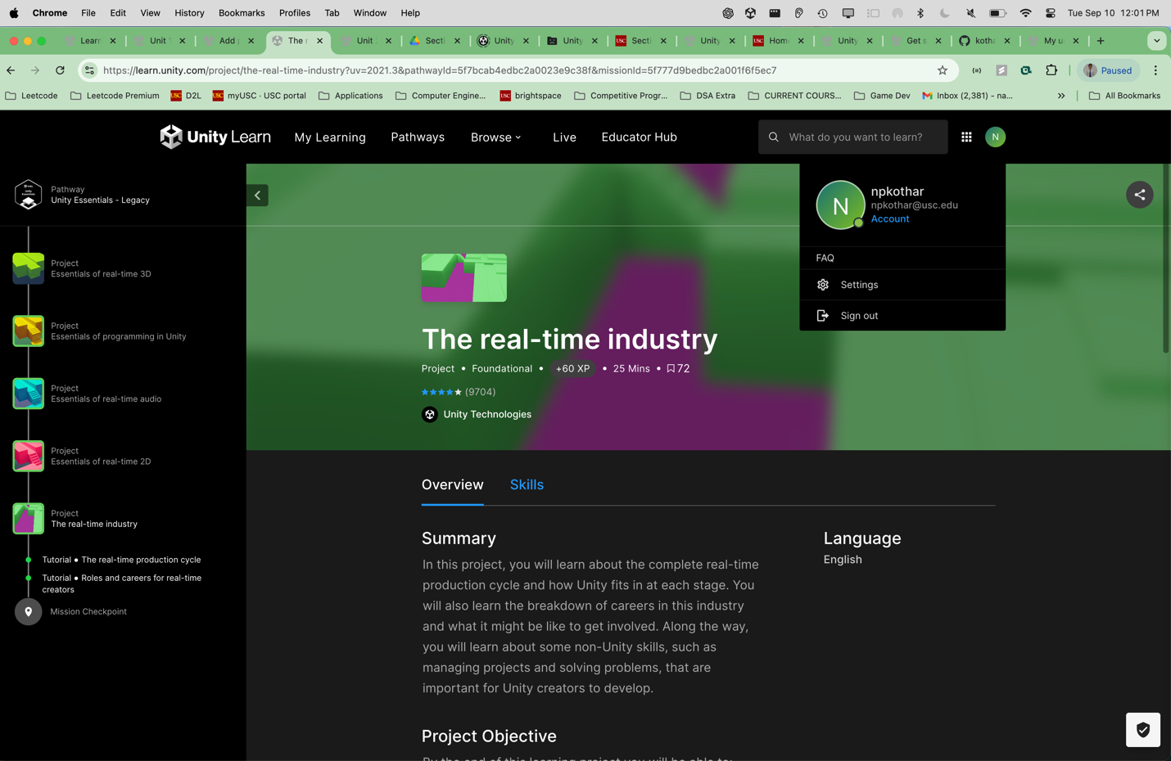

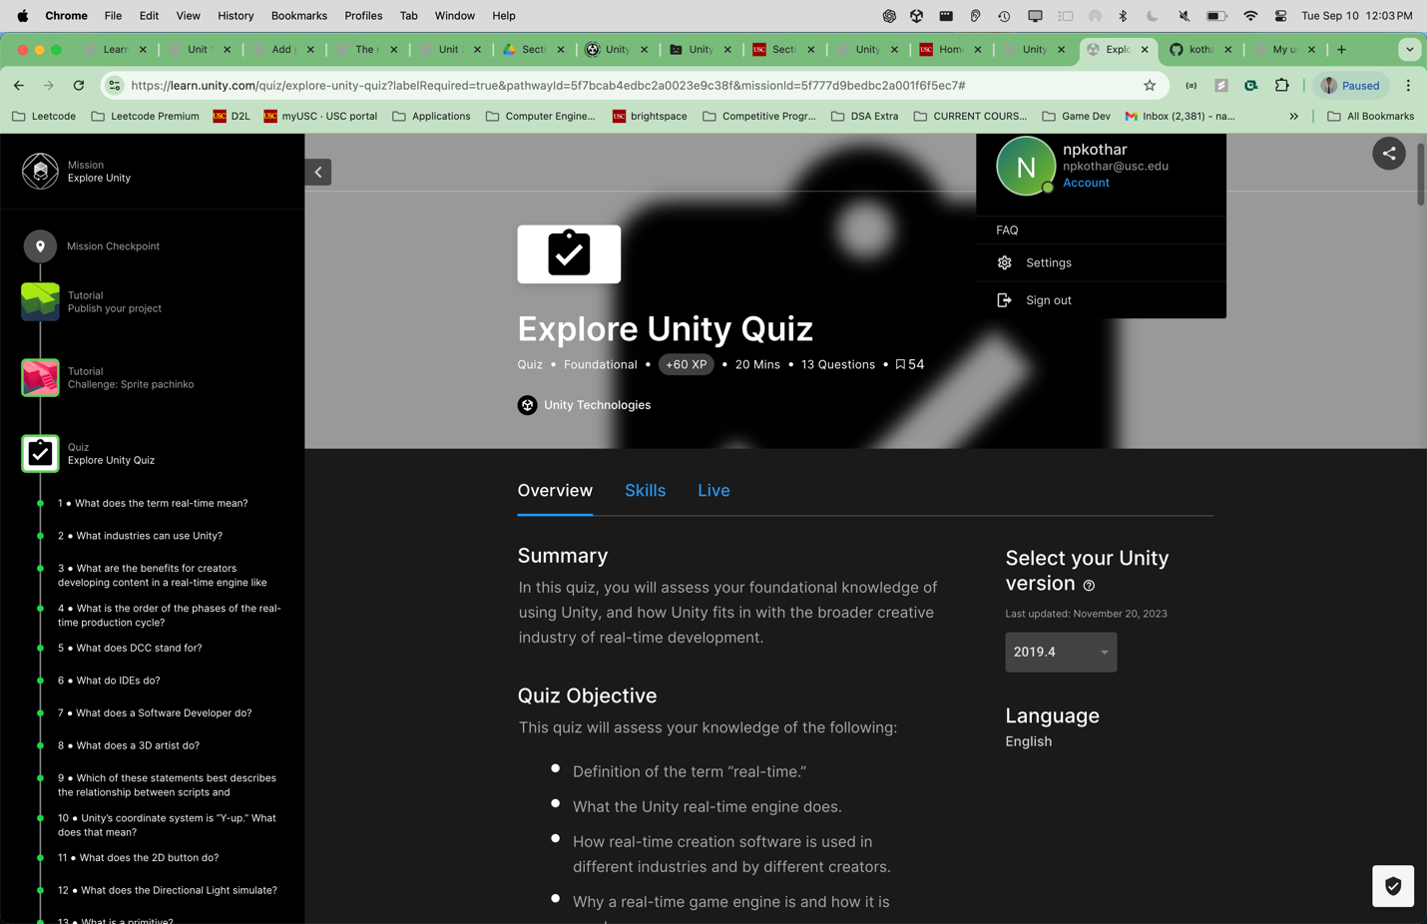

Mission checkpoint(finished everything)

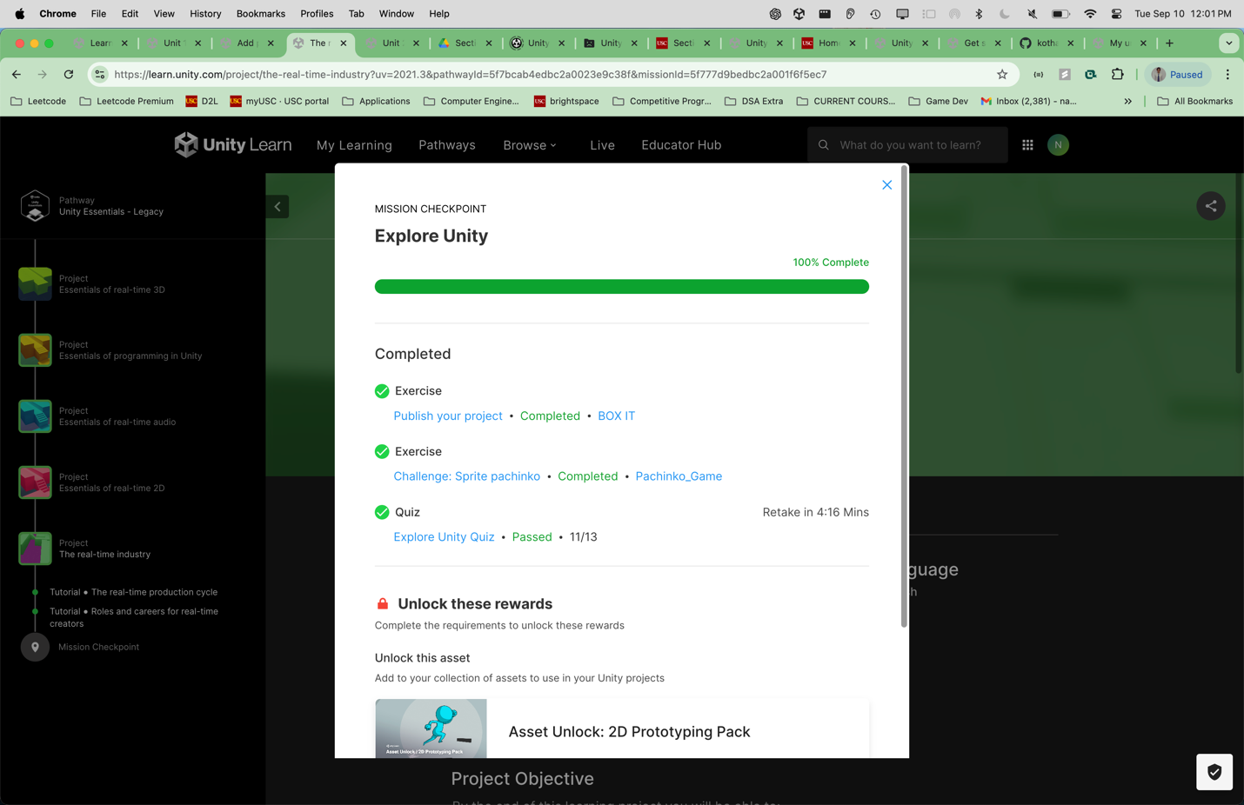

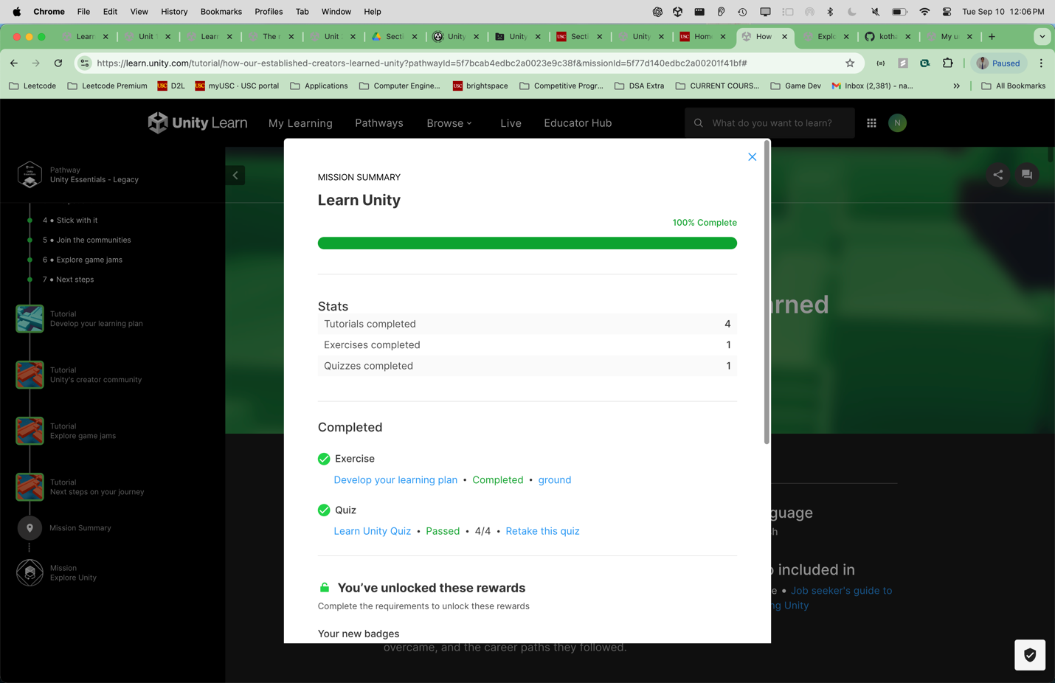

JUNIOR PROGRAMMER PATHWAY:-

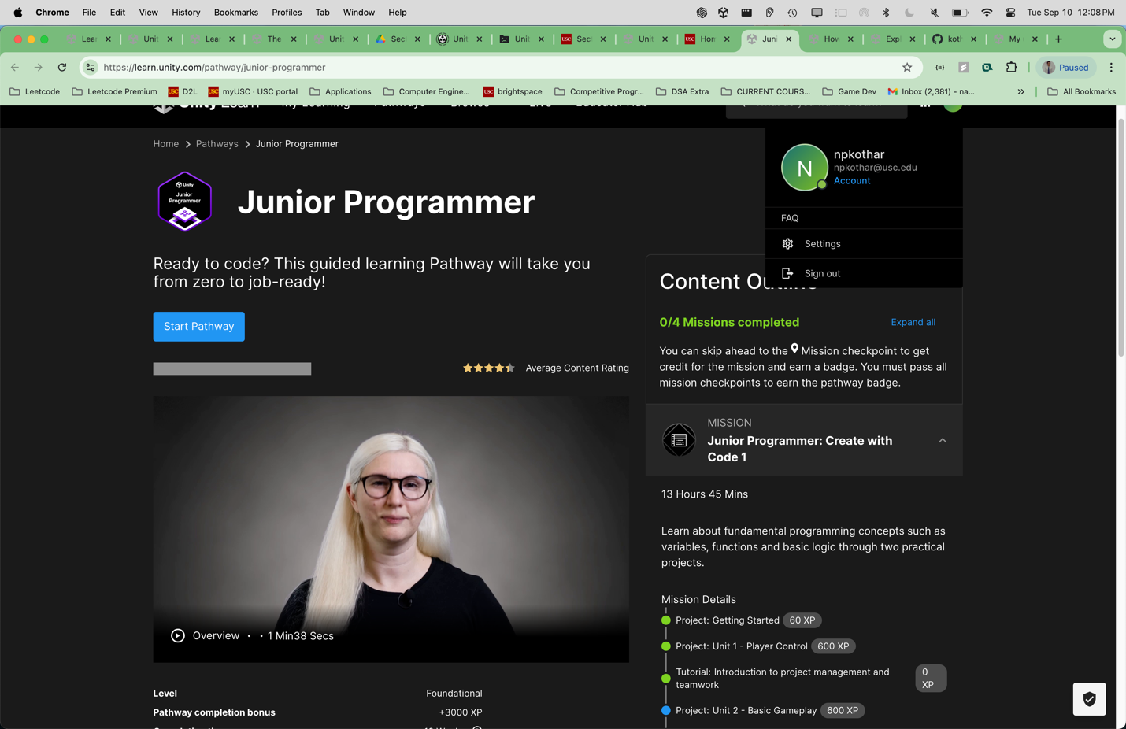

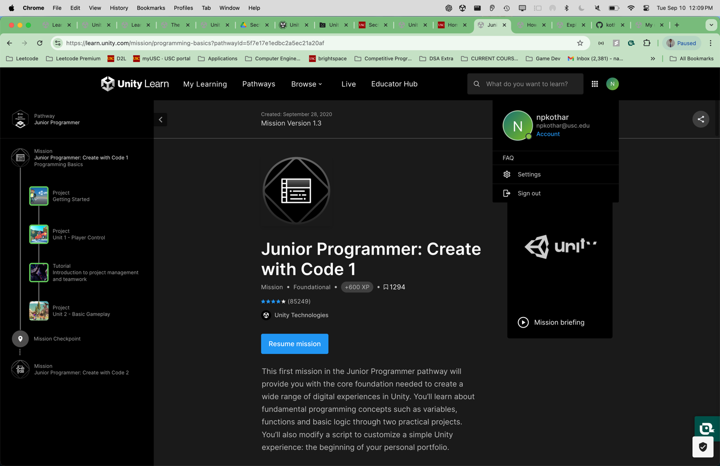

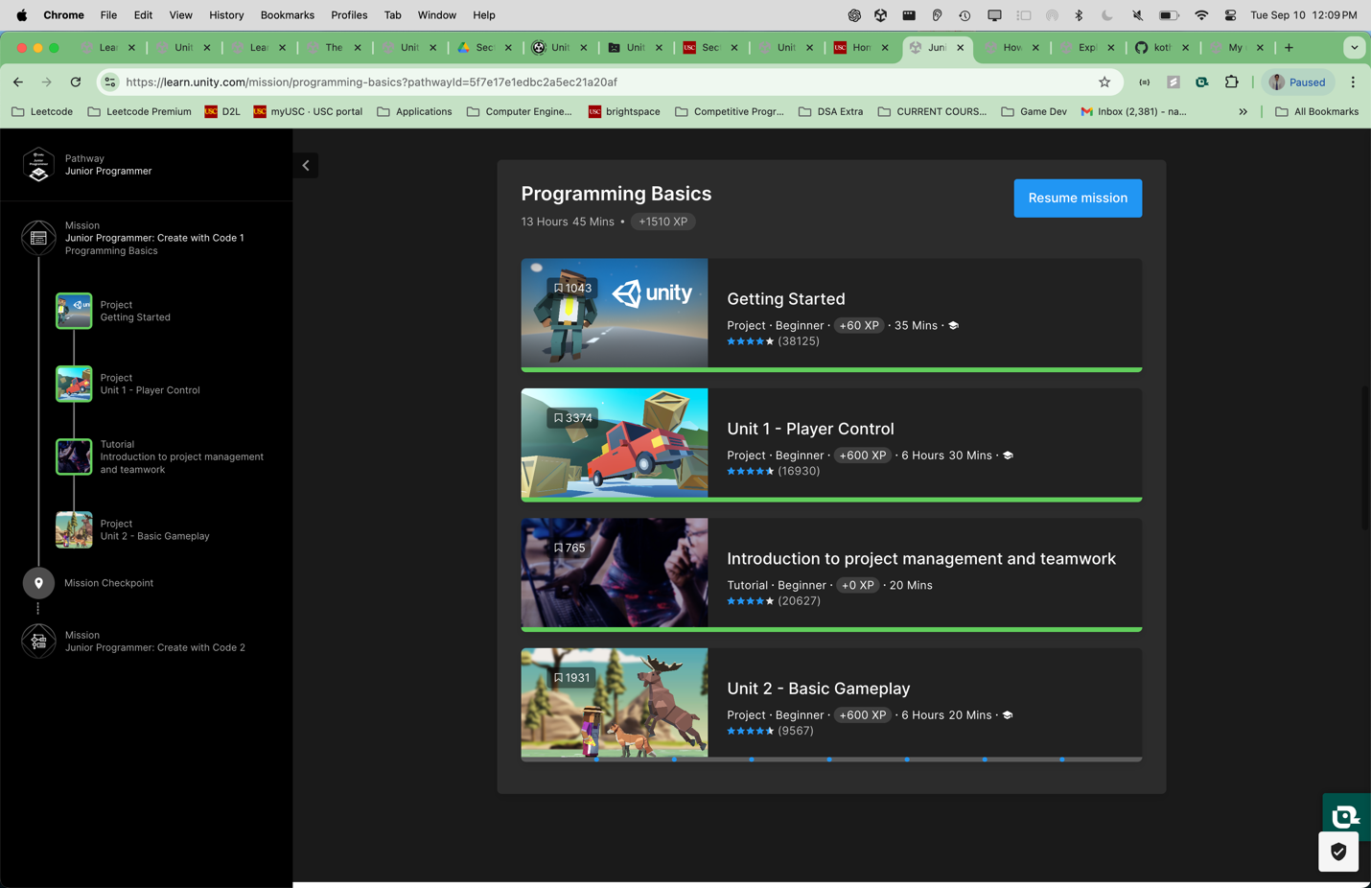

Quiz proof:-

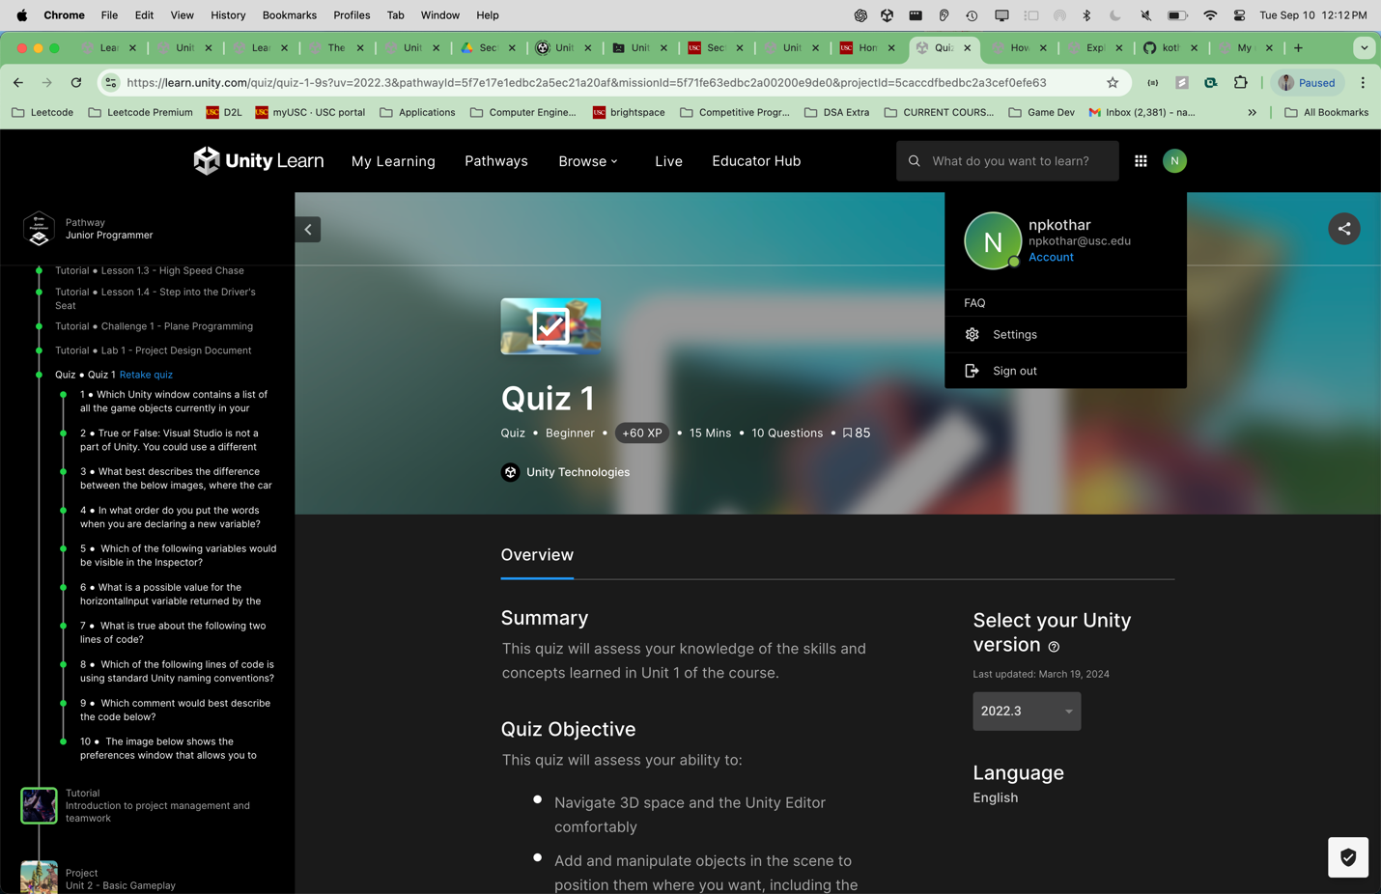

* + **Playable deliverable (25 pts)**
    - **Microgame (Optional)**: Tinker with and modify a pre-built microgame - <https://play.unity.com/en/games/b9568e2e-8bf5-4388-b737-ba3921812528/shootinggameweb>
    - **Essentials of real-time 3D (Required, 10 pts)**: Published prototype with 3D objects that have been moved and/or scaled, materials, directional light, imported assets. Complete challenge of creating a game where a ball moves along a thin platform above lava - <https://play.unity.com/en/games/6cf900ac-9412-4eac-968c-1bf3e04ec2fb/box-it>
    - **Essentials of programming (Required, 5 pts)**: Unity project where scripts programmatically alter object properties - <https://play.unity.com/en/games/60626e69-0732-443b-a7ff-a655fdf979c7/Essentials_Programming_Project>
    - **Essentials of real-time audio** **(Optional)**: Prototype with audio sources, clips, and listeners. Audio should come from particular points in space, change volume with distance. Complete challenge of making sound move outside the window. – optional so left

**Essentials of real-time 2D (Required, 10 pts)**: Prototype with 2D object manipulation. Complete challenge of making a pachinko game - <https://play.unity.com/en/games/6b1db10f-db4a-4706-a34b-49bb98ee398f/pachinkogame>

* **Unity Junior Programming Pathway (60 pts)**
  + **Getting Started (Required) (5 pts) - ✅**
  + **Unit 1 - Player Control (Required) (50 pts)**
    - **Car Prototype (20 pts)**: Drivable car with turning and camera following behind - <https://play.unity.com/en/games/a6d7287a-c9e9-4c99-97d0-ed016fa0a5f5/car-run>
    - **Plane Prototype (20 pt)**: Flying plane prototype with the following things present
      * Plane has some velocity without user input (non stationary)
      * Plane moves forward, not backward
      * Plane moves at a reasonable speed (not too fast)
      * Plane tilts with up/down arrows, and nothing else
      * Camera is beside the plane, not in front of it

Camera follows the plane - <https://play.unity.com/en/games/c32bc0c7-d1bd-4f11-a2bd-d4d5569bcc74/flappy-plane>

Naman Kothari Design Doc:-

<https://uscedu-my.sharepoint.com/:w:/g/personal/npkothar_usc_edu/ERXXgg6kn2VDlxNvOaUTYRIBd5AVviIoaFYW_6jGr33TjA?e=vYWeQP>